**IMACALL**

**CHAT & CALL WITH YOUR FAVOURITE AI CHARACTERS**

**DETAILED DESIGN DOCUMENTS**

**DOCUMENT CHANGE RECORD TABLE**

*A – Create new, M – Modify, D – Delete

| Ngày  thay đổi | Vị trí  thay đổi | A*  M, D | Nguồn gốc | Phiên  bản cũ | Mô tả thay đổi | Phiên  bản mới |
| --- | --- | --- | --- | --- | --- | --- |
|  |  |  |  |  |  |  |
|  |  |  |  |  |  |  |
|  |  |  |  |  |  |  |
|  |  |  |  |  |  |  |
|  |  |  |  |  |  |  |
|  |  |  |  |  |  |  |
|  |  |  |  |  |  |  |
|  |  |  |  |  |  |  |
|  |  |  |  |  |  |  |
|  |  |  |  |  |  |  |
|  |  |  |  |  |  |  |
|  |  |  |  |  |  |  |
|  |  |  |  |  |  |  |
|  |  |  |  |  |  |  |

**TABLE OF CONTENTS**

**1.** **INTRODUCTION 5**

1.1 Purpose5

1.2 Scope5

1.3 Concepts, Terminology 5

1.4 References 5

1.5 Document Description5

**2.** **SOLUTION OVERVIEW 6**

**3.** **DETAILED DESIGN 7**

3.1 LOGIN SUBSYSTEM7

3.1.1 General functional information7

3.1.2 Screen 9

3.1.3 Detailed description of components 12

3.1.4 WorkFlow 17

3.2 Q&A SUBSYSTEM 18

3.2.1 General functional information18

3.2.2 Screen 19

3.2.3 Detailed description of components 21

3.2.4 WorkFlow 24

3.3 CALL SYSTEM 27

3.3.1 General functional information 27

3.3.2 Screen 27

3.3.3 Detailed description of components 29

3.3.4 WorkFlow 37

3.4 CHAT HISTORY MANAGEMENT 39

3.4.1 General functional information 39

3.4.2 Screen 39

3.4.3 Detailed description of components 40

3.4.4 WorkFlow 43

3.5 USER PROFILE 44

3.5.1 General functional information 44

3.5.2 Screen 44

3.5.3 Detailed description of components 47

3.5.4 WorkFlow 49

3.6 CHARACTER REQUIREMENT 50

3.6.1 General functional information 50

3.6.2 Screen 50

3.6.3 Detailed description of components 53

3.6.4 WorkFlow 56

3.7 ADMIN USER 57

3.7.1 General functional information 57

3.7.2 Screen 58

3.7.3 Detailed description of components 60

3.7.4 WorkFlow 64

**4.** **COMMON AND REUSABLE DESIGN 65**

**5.****APPENDIX 65**

**1. INTRODUCTION**

The introduction to the architecture documentation system should provide a summary of the document including the purpose of the document, concepts, terminology, and reference links.

**1.1 Objectives**

This document provides a comprehensive picture of the system through a number of different architectural models that describe the system from different perspectives. This document is expected to capture and communicate important decisions about the architecture of the system.

This section defines the role or purpose of the architecture documentation system and briefly introduces the local layout of the document. It is necessary to specify who will read this document and how it will be used

**1.2 Scope**

Briefly describe what the documentation architecture system serves? What is the impact or influence of this document?

**1.3 Concepts, terms**

This section will provide definitions of all concepts, terms… used in the document architecture system.

**1.4 References**

The section lists all external references. Each document is identified by its name, author and release date and should also indicate whether it is a document that can be used or is only a reference document. If appropriate, the report number, journal name and the document are distributed functionally.

**1.5 Description documents**

This section will introduce what is left out of the above 04 items of the document architecture system and introduce the internal layout of the document architecture system.

**2. SOLUTION OVERVIEW**

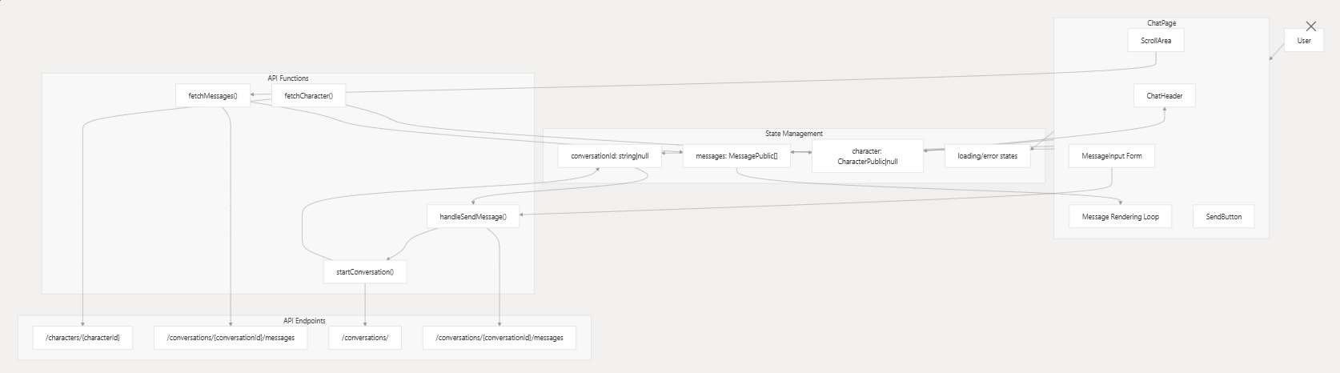

**Communication model with other functional systems/modules**

**3. DETAILED DESIGN**

**3.1 LOGIN SUBSYSTEM**

3.1.1. General functional information

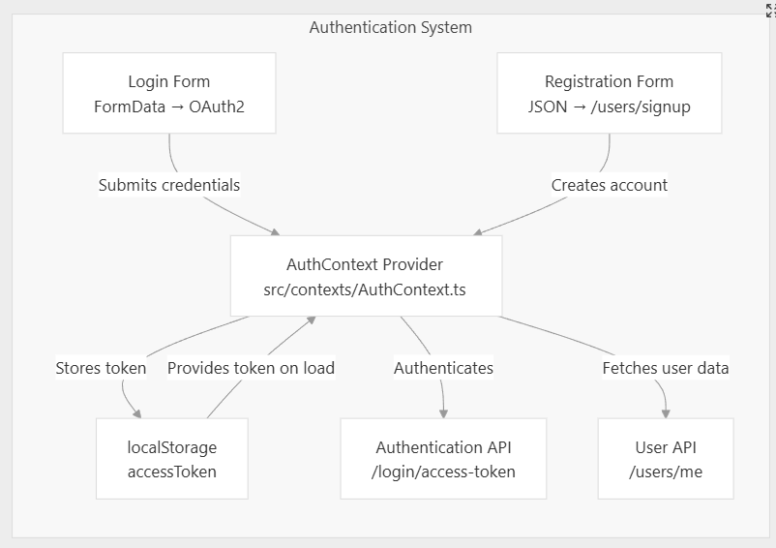

This function allows users to submit requests to register an account and log in to the Imacall.

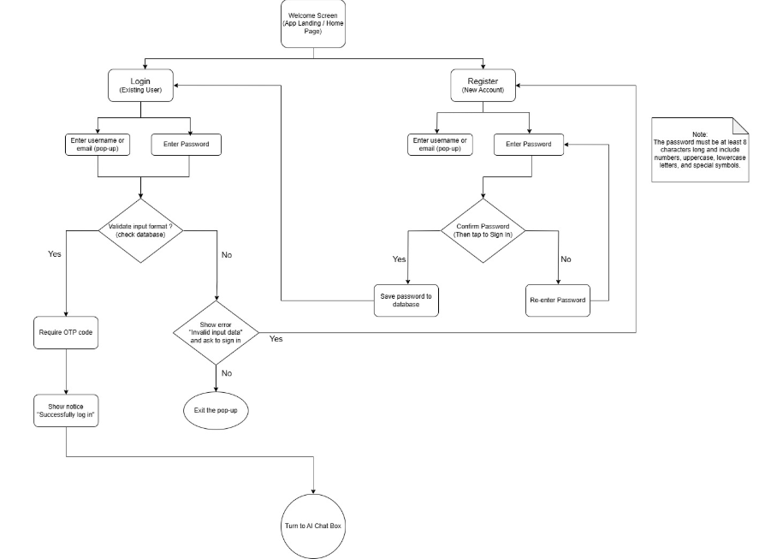

**3.1.2. Screen**

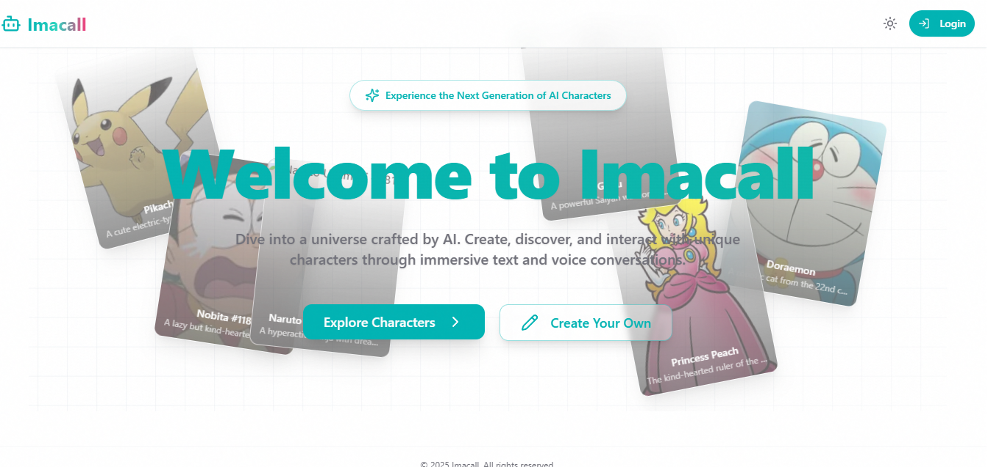

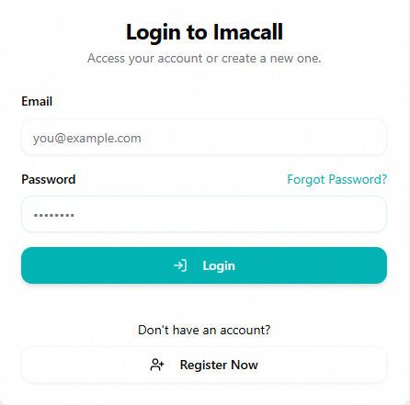

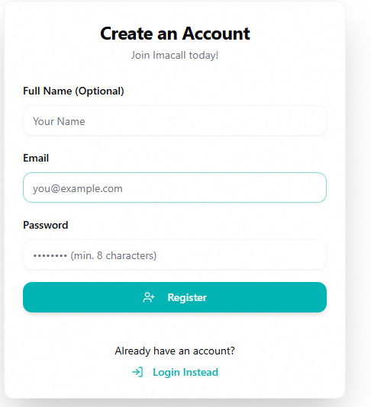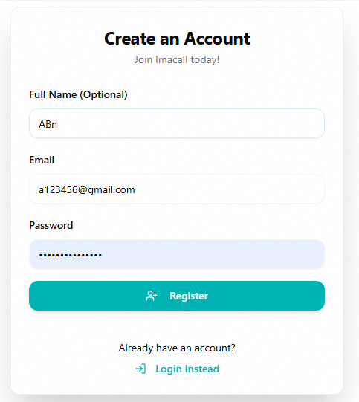

**3.1.3. Detailed description of components**

| ID | Name | Data Type  [Data Length] | Initial value | **Description** (Mapping with database if any) |
| --- | --- | --- | --- | --- |
| “Login” screen | | | | |
|  | Registration | Button | N/A | * Display Message: Account Not Authorized Yet * Navigates the user to the **Complete Registration** screen. |
|  | "Your account does not have login access yet. Please register to continue." | Label |  | * Notification Message: "Your account does not have login access yet. Please register to continue." |
|  | Registration request has been denied. | Label |  | * Display a message in case a user's registration request is rejected |
| “Registration Confirmation” screen | | | | |
|  |  | Button |  | * When the user clicks on the icon, the app navigates to the initial login screen |
|  | Confirm registration | Label | Confirm registration | * Displays the label “Sign up success” |
|  | Please confirm the information and specify the purpose of use. | Label |  | * Notification Message: “Please confirm the information and specify the purpose of use”. |
|  | Account information | Label | Account information |  |
|  | Name | Label |  | * Display and username corresponding to the SSO account sending the registration request * Display data taken from the fullName field (Registration API) |
|  | ID | Label |  | * Displays and username corresponding to the SSO account sending the registration request * Display data is taken from the userID field (Registration API) |
|  | Title | Label | NULL | * Displays the user's position title corresponding to the SSO account sending the registration request * The displayed data is taken from the position field (Registration API – data taken from the system) |
|  | Power | Label | NULL | * Displays system access permissions corresponding to user unit * The displayed data is taken from the areaName field (Registration API) |
|  | Submit registration | Button |  | * Button used to send a request to register a account to the CMS system * When pressing the button, the system switches to the screen notifying successful registration |
|  | Already have an account | Label |  | * Display label “Already have a Imacall account?” |
|  | Log in | Button | N/A | * Hyperlink to navigate to Login screen |
| Registration successful screen | | | | |
|  | You have registered to use | Label |  | * Notification Message:   “You have registered to use “ |
|  | Please wait for response from Administrator | Label |  | * Notification Message:   “Please wait for response from Administrator” |
| Popup “Under review” | | | | |
|  | Under review | Label |  | * Popup “Under review” |
|  | Account is under review | Label |  | * Display message “Account is under review” |
|  | Confirm | Button | N/A | * The user presses the button to confirm the notification and closes the popup, the system displays the Login screen with the Register button and the message "Please wait for a response from the Administrator |
|  | x | Buton | N/A | * The user clicks on the icon to close the popup, the system displays the Login screen with the Register button and the message "Please wait for a response from the Administrator” |
| Popup “Rejected” | | | | |
|  | Rejected | Label |  | * Display label “Rejected” |
|  | Your account has been denied | Label |  | * Display label “Your account has been denied” |
|  | Confirm | Button | N/A | * The user presses the button to confirm the notification and closes the popup, the system displays the Login screen with the Register button and the message "Please wait for a response from the Administrator |
|  | x | Buton | N/A | * The user presses the button to confirm the notification and closes the popup, the system displays the Login screen with the Register button and the message "Please wait for a response from the Administrator |

**3.1.4.Workflow**

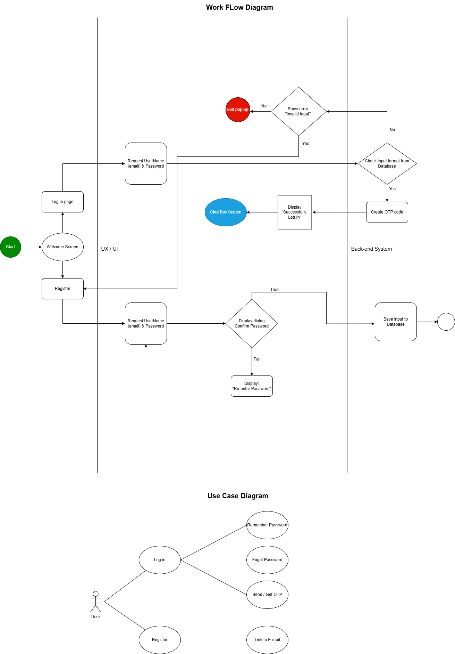

**3.2 Q&A SUBSYSTEM**

**3.2.1. General function information**

The Q&A Subsystem is responsible for handling user questions and generating relevant, context-aware responses from AI characters. It enables interactive communication in the form of question-and-answer dialogue, simulating intelligent, conversational behavior. This subsystem plays a central role in the AI interaction flow, acting as the core logic behind the user’s inquiry processing. It leverages the AI Character System and integrates with the Message History system to ensure continuity and contextual relevance.

**3.2.2. Screen**

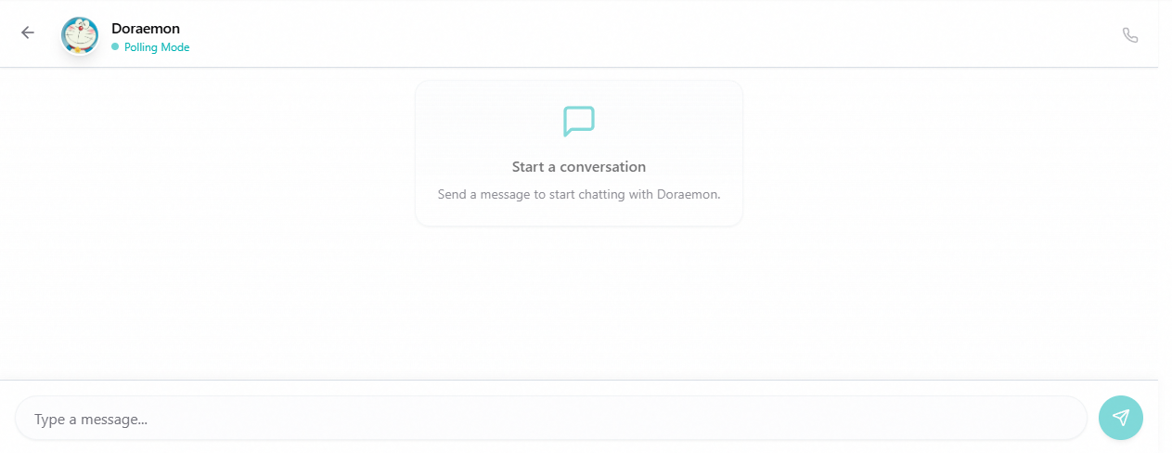

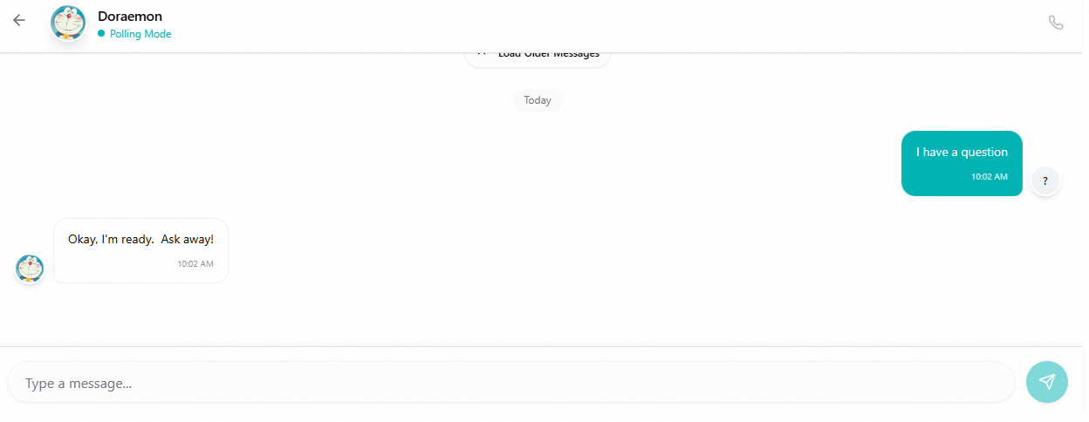

**3.2.3. Detailed component description**

| ID | Name | Data Type  [Data Length] | Input/Output | Initial value | Description (Mapping with database if any) |
| --- | --- | --- | --- | --- | --- |
| 1 | id | UUID | Output | auto-generated | Primary key for the conversation |
| 2 | user_id | UUID | Output | Required | Foreign key to the user participating in the conversation |
| 3 | character_id | UUID | Input | Required | Foreign key to the character in the conversation |
| 4 | created_at | DateTime | Output | Current UTC time | When the conversation was created |
| 5 | last_interaction_at | DateTime | Output | None | When the last message was exchanged, used for sorting |
| **Message Model** | | | | | |
| 1 | id | UUID | None | auto-generated | Primary key for the conversation |
| 2 | conversation_id | UUID | Output | Required | Foreign key to the user participating in the conversation |
| 3 | content | String (5000) | Input | Required | Foreign key to the character in the conversation |
| 4 | sender | Enum | Output | Required | When the conversation was created |
| 5 | timestamp | DateTime | None | Current UTC time | When the last message was exchanged, used for sorting |

**3.2.4. Workflow**

**~~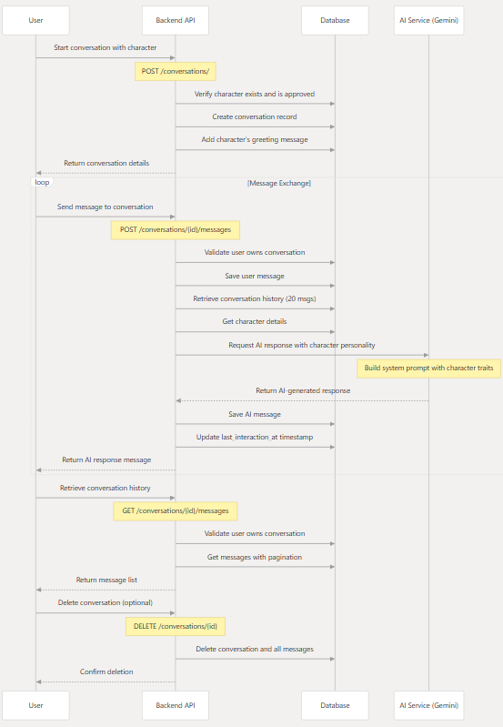~~**

**The core components of this system include:**

**Data Models:**

Character model for defining AI personalities

Conversation model for tracking dialogues

Message model for storing individual exchanges

**API Endpoints:**

Endpoints for starting

Endpoints for sending messages and receiving AI

**AI Service:**

A pluggable architecture supporting multiple LLM

Logic for generating AI responses based on character personality and conversation history

**The conversation flow works as follows:**

User creates or selects a conversation with an AI character

User sends a message to the conversation

Backend stores the user message

Backend retrieves conversation history (limited to recent messages for context)

AI service generates a response based on character profile and conversation history

Backend stores the AI response

Response is returned to the user

This is implemented in the send_message function in the conversations router

**3.3 VOICE CALL SYSTEM**

**3.3.1 General functional information**

The CALL SYSTEM (Character & AI-powered Language Learning system) is a core component of the Imacall backend that enables users to interact with AI characters through conversations.

1. Creation of custom AI characters with defined personalities
2. Starting conversations with approved characters
3. Exchanging messages with characters powered by LLM (Large Language Model) providers
4. Managing conversation history

**3.3.2 Screen**

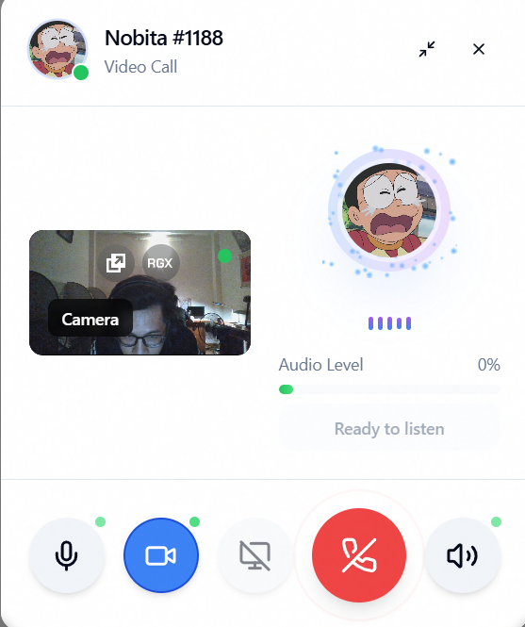

**3.3.3 Detailed description of components**

1. **Character Models**

| ID | Name | Data Type  [Data Length] | Input/Output | Initial value | Description (Mapping with database if any) |
| --- | --- | --- | --- | --- | --- |
| 1 | id | UUID | Output | Auto-generated UUID4 | Primary key for the character |
| 2 | name | String (max 100) | Input | Required | Character's name, indexed |
| 3 | description | Text | Input | None | General description of the character |
| 4 | image_url | String | Input | None | URL to profile image |
| 5 | greeting_message | Text | Input | None | Initial message when conversation starts |
| 6 | scenario | Text | Input | None | Character’s environment/situation |
| 7 | category | String | Input | None | Category for filtering, indexed |
| 8 | language | String | Input | None | Primary language, indexed |
| 9 | tags | List[String] / Text | Input | None | Searchable tags stored as text |
| 10 | voice_id | String | Input | None | For TTS integration |
| 11 | personality_traits | Text | Input | None |  |
| 12 | writing_style | Text | Input | None | Expression style |
| 13 | background | Text | Input | None | Character’s history |
| 14 | knowledge_scope | Text | Input | None | Knowledge limits |
| 15 | quirks | Text | Input | None | Unique behaviors |
| 16 | emotional_range | Text | Input | None | Emotion expression range |
| 17 | popularity_score | Integer | None | 0 | Placeholder for rating |
| 18 | status | Enum (CharacterStatus) | None | PENDING | Approval status |
| 19 | is_public | Boolean | Input | True | Shown in public lists if approved |
| 20 | is_featured | Boolean | Input | False | Highlighted in UI |
| 21 | admin_feedback | Text | Output | None | Feedback on rejection/changes |
| 22 | creator_id | UUID | Input | Required | Reference to user |
| 23 | created_at | DateTime | Output | Current time | When created |
| 24 | updated_at | DateTime | Output | Current time | When last updated |

**Character Creation:**

User submits a character through the /characters/submit endpoint

System creates a Character record with status=PENDING

**Admin Review:**

Administrators review pending characters through admin endpoints

Admin approves or rejects the character submission

**Character Availability:**

Only APPROVED characters can be used in conversations

The API enforces this check when starting conversations

1. **Conversation Model**

| ID | Name | Data Type  [Data Length] | Input/Output | Initial value | Description (Mapping with database if any) |
| --- | --- | --- | --- | --- | --- |
| 1 | id | UUID | Output | Auto-generated UUID4 | Primary key |
| 2 | user_id | UUID | Output | None | FK to user |
| 3 | character_id | UUID | Input | Required | FK to character |
| 4 | created_at | DateTime | Output | Current UTC time | When created |
| 5 | last_interaction_at | DateTime | Output | None | Last message time |

**Start Conversation Request:**

User sends a request to start a conversation with a character

**Character Validation:**

System checks if the character exists and is approved

**Conversation Creation:**

System creates a new conversation record linking the user and character

**Initial Greeting:**

If the character has a greeting_message, it's added as the first AI message

1. **Message Model**

| ID | Name | Data Type  [Data Length] | Input/Output | Initial value | Description (Mapping with database if any) |
| --- | --- | --- | --- | --- | --- |
| 1 | id | UUID | Output | Auto-generated UUID4 | Primary key |
| 2 | conversation_id | UUID | Input | Required | FK to conversation |
| 3 | content | String (max 5000) | Input | Required | Message text |
| 4 | sender | Enum (MessageSender) | Output | Required | Who sent it |
| 5 | timestamp | DateTime | Output | Current UTC time | Sent time |

**User Sends Message:**

User sends a message to an existing conversation

**Conversation Validation:**

System verifies the conversation exists and belongs to the user

**Save User Message:**

System saves the user's message to the database with sender=USER

**Retrieve Conversation Context:**

System gets recent message history (limited to 20 messages for context)

System ensures the character object is loaded for personality details

**Generate AI Response:**

System calls the AI ​​service with character details and conversation history

**AI Service Processing:**

AI service selects the active provider (default: Gemini)

Provider builds a system prompt from character attributes

Provider formats conversation history for the LLM

Provider sends the request to the LLM API

**Save and Return AI Response:**

System saves the AI's response as a new message with sender=AI

System updates the conversation's last_interaction_at timestamp

System returns the AI ​​message to the user

1. **AI Service Components**

| ID | Name | Input | Output | Description |
| --- | --- | --- | --- | --- |
| 1 | __init__ | api_key: str | None | Initialize with API key |
| 2 | get_response | character, history | str | Generate AI response |

**Provider Initialization:**

System initializes available providers based on configured API keys

**Provider Selection:**

Administrators can view available providers

Administrators can set the active provider

**Fallback Mechanism:**

If the active provider is unavailable, system tries fallback providers

1. **GeminiProvider Implementation**

| ID | Field | Data Type | Input/Output | Initial Value | Description |
| --- | --- | --- | --- | --- | --- |
| 1 | model | GenerativeModel | None | 'gemini-1.5-flash-latest' | Model instance |
| 2 | safety_settings | Dict | None |  | Filtering config |

**3.3.4 WorkFlow**

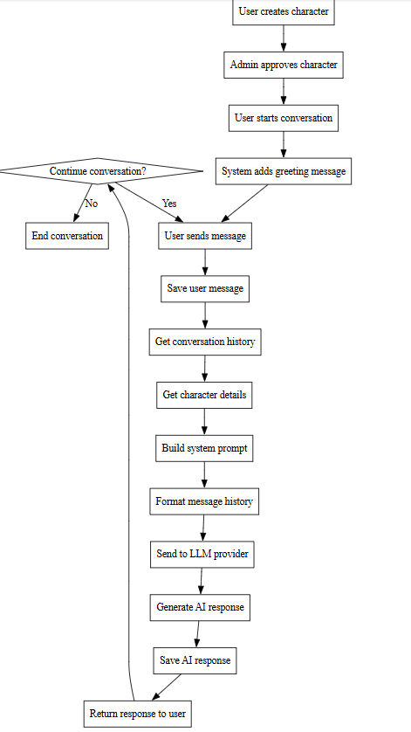

**3.4 CHAT HISTORY MANAGEMENT**

**3.4.1. General function information**

The Imacall application uses a JWT (JSON Web Token) based authentication system with a RESTful API backend and a React-based frontend. The system implements secure user authentication, password management, and session handling.

**3.4.2. Screen flow**

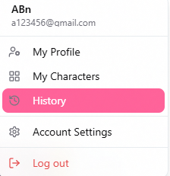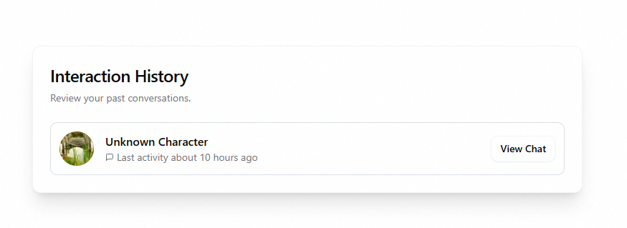

**3.4.3. Detailed component description**

| ID | Name | Data Type  [Data Length] | Initial value | Description (Mapping with database if any) |
| --- | --- | --- | --- | --- |
| 1 | Message | SQLModel table | N/A | Stores individual messages in conversations |
| 2 | MessageSender | Enum | N/A | Identifies message sender (USER or AI) |
| 3 | get_conversation_messages | Function | N/A | Retrieves messages for a conversation |
| 4 | create_message | Function | N/A | Creates new messages in the database |
| 5 | get_conversation_messages_count | Function | N/A | Counts total messages in a conversation |

**1. Message Retrieval Functions**

get_conversation_messages: Retrieves messages for a specific conversation with pagination

This function takes a conversation ID, skip (offset), and limit parameters, orders messages chronologically by timestamp, and returns a sequence of Message objects. The default limit is set to 1000 messages but is typically adjusted based on context needs.

get_conversation_messages_count: Counts the total number of messages in a conversation

**2. Message Creation Function**

create_message: Creates and persists a new message in the database.

This function takes a session, message content, conversation ID, and sender type, creates a new Message object, persists it to the database, and returns the created message with its generated ID.

**3. Conversation Management Functions**

update_conversation_last_interaction: Updates the timestamp of the last interaction

This function is important for sorting conversations by recency, as it updates the last_interaction_at timestamp to the current UTC time whenever a new message is exchanged.

get_conversation: Retrieves a single conversation by its ID

get_user_conversations: Gets a list of conversations for a specific user

get_user_conversations_count: Counts the total number of conversations for a user

delete_conversation: Deletes a conversation and its associated messages via cascade

**3.4.4 Workflow**

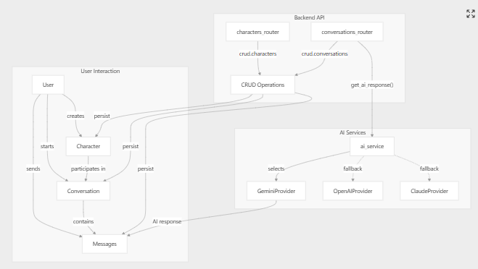**\**

**3.5 USER PROFILE**

**3.5.1 General functional information**

The user profile system in Imacall backend follows a standard pattern with separate models for database representation, API input, and API output. The system enforces validation rules for email format, password length, and field sizes. Regular users can update their own profile information (name and email) and change their password, while administrators can create, update, and delete users with additional control over superuser status and account activation.

**3.5.2 Screen**

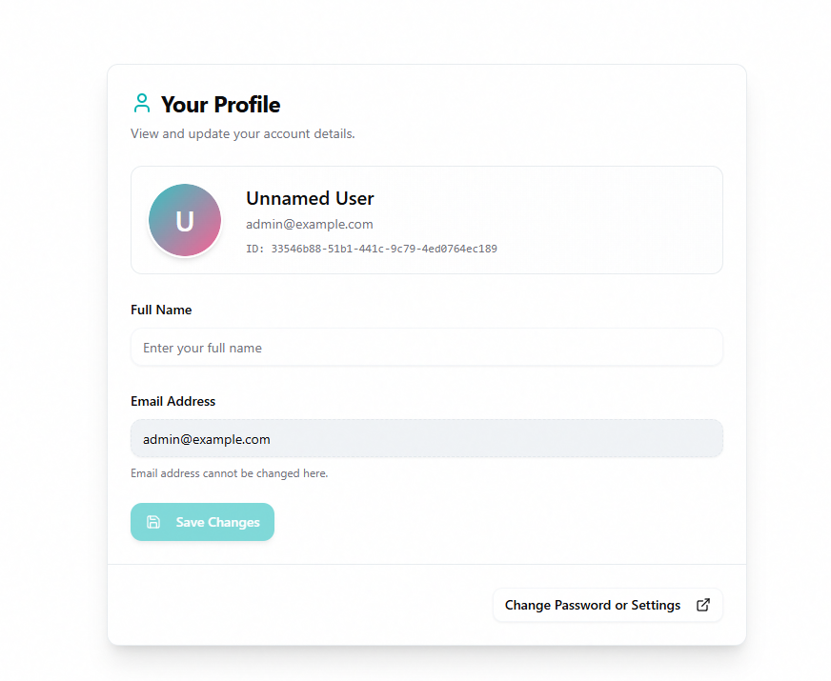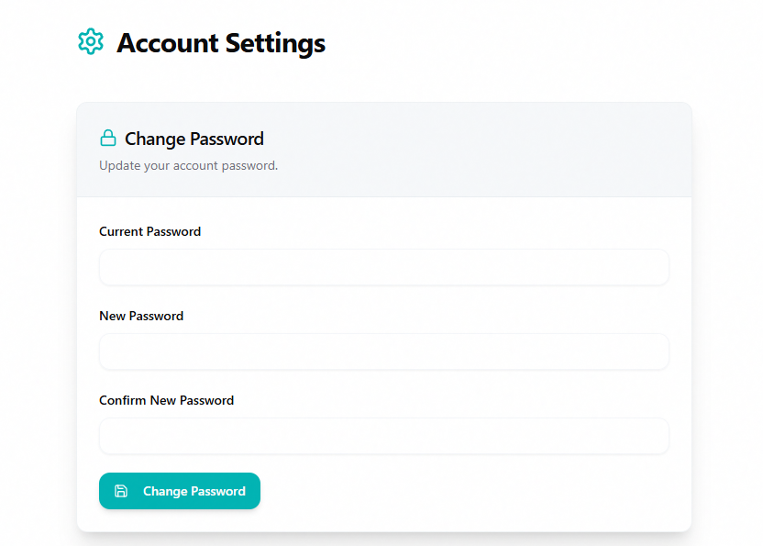

**3.5.2 Detailed description of components**

| ID | Field | Data Type | Input/Output | Initial Value | Description |
| --- | --- | --- | --- | --- | --- |
| 1 | id | uuid.UUID | Output only | Auto-generated UUID | Unique identifier |
| 2 | email | EmailStr | Input/Output | Required input | User's email address |
| 3 | is_active | bool | Input/Output | True | Account status |
| 4 | is_superuser | bool | Input/Output | False | Admin privileges |
| 5 | full_name | str or None | Input/Output | None (optional) | User's full name |
| 6 | hashed_password | str | Internal only | Generated from password | Encrypted password |
| 7 | items | list[Item] | Relationship | Empty list | Related items |
| 8 | created_characters | list[Character] | Relationship | Empty list | Created characters |
| 9 | conversations | list[Conversation] | Relationship | Empty list | User conversations |

**3.5.4 Workflow**

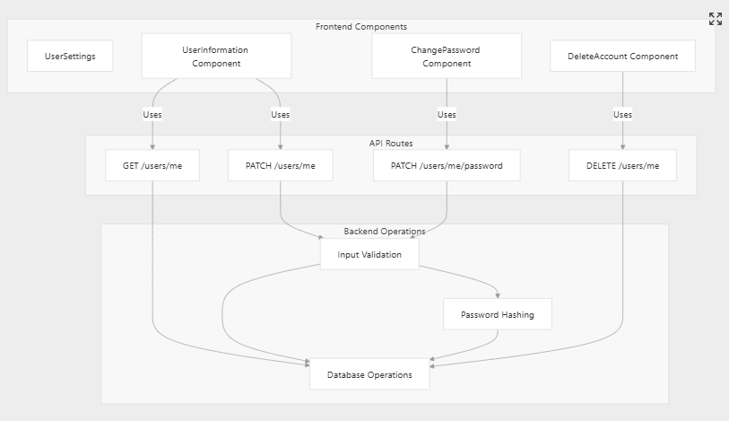

**3.6 CHARACTER REQUIREMENT**

**3.6.1 General functional information**

The Character model in the Imacall backend has several required and optional fields that define an AI character's personality and behavior:

**Basic Fields (Required):**

* name: String (max 100 chars), required, indexed for searching
* status: Enum (PENDING, APPROVED, REJECTED) - controls whether a character is available for conversations
* creator_id: UUID reference to the user who created the character

**Personality Fields (Optional but Important):**

* description: Text field for general character description
* greeting_message: Initial message sent when starting a conversation
* scenario: Text describing the character's environment or situation
* personality_traits: Text describing character traits (e.g., "Curious, Witty, Cautious")
* writing_style: Text describing how the character expresses themselves
* background: Text describing the character's history
* knowledge_scope: Text describing what the character knows/doesn't know
* quirks: Text describing unique habits or behaviors
* emotional_range: Text describing how the character expresses emotions

**3.6.2 Screen**

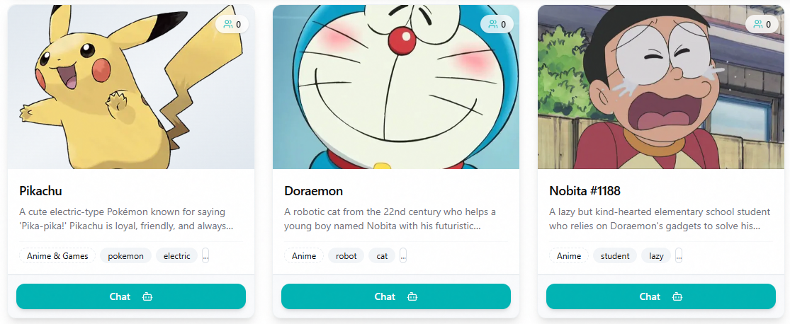

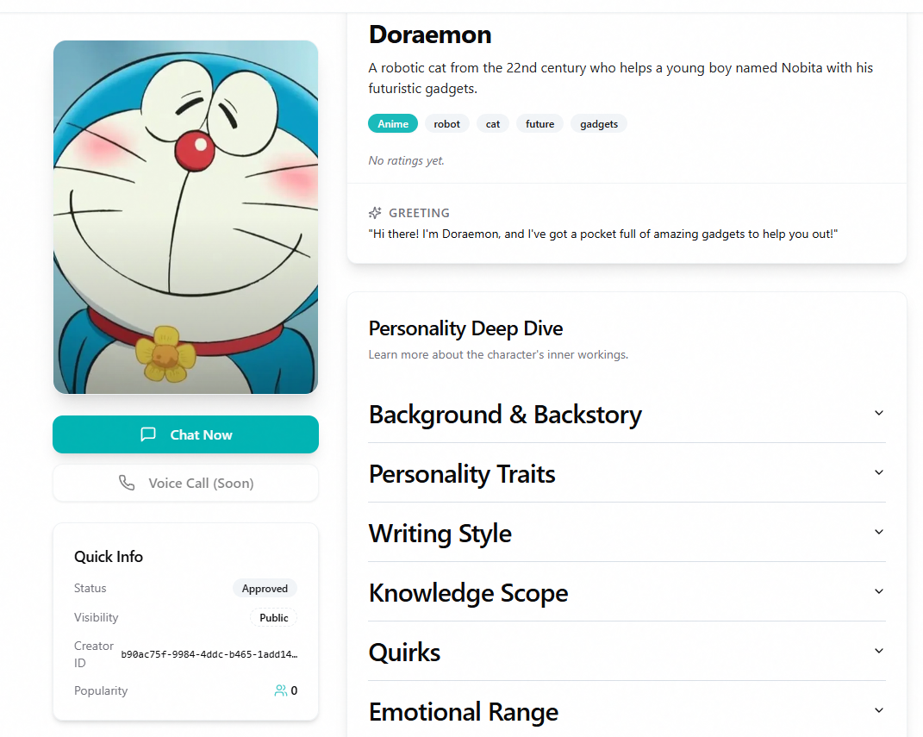

**3.6.3 Detailed description of components**

| ID | Name | Data Type  [Data Length] | Description |
| --- | --- | --- | --- |
| 1 | id | UUID | Primary key |
| 2 | creator_id | UUID | Reference to User who created the character |
| 3 | name | String | Character's name |
| 4 | description | Text | General description |
| 5 | image_url | String | Optional profile image URL |
| 6 | greeting_message | Text | Initial message sent when starting a conversation |
| 7 | scenario | Text | Character's environment or situation or situation |
| 8 | category | String | General category for filtering |
| 9 | language | String | Character's primary language |
| 10 | tags | String | Searchable tags |
| 11 | personality_traits | Text | Traits that define the character's behavior |
| 12 | writing_style | Text | Character's typical expression style |
| 13 | background | Text | Character's history |
| 14 | knowledge_scope | Text | What the character does/doesn't know |
| 15 | quirks | Text | Unique habits or behaviors |
| 16 | emotional_range | Text | How the character expresses emotions |
| 17 | status | Enum | PENDING, APPROVED, or REJECTED |
| 18 | is_public | Boolean | Whether visible in public listings |
| 19 | is_featured | Boolean | Whether highlighted in the UI |

**3.6.4 WorkFlow**

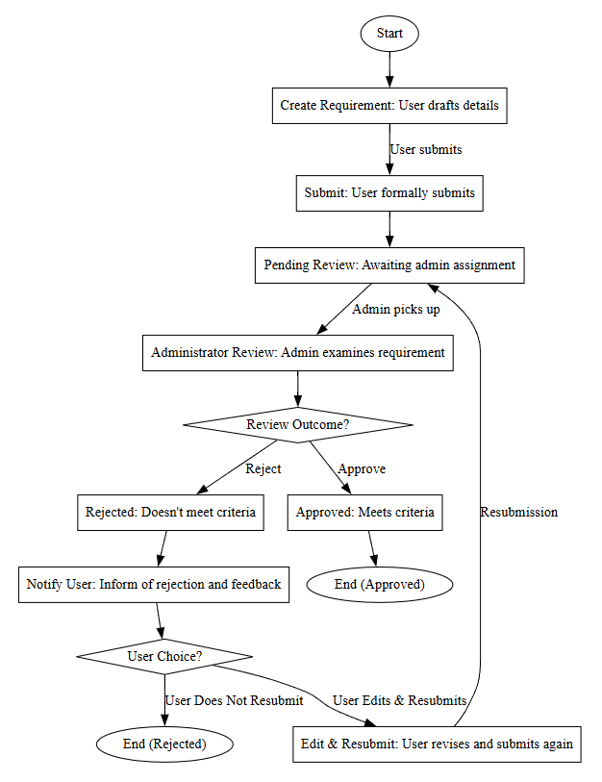

**3.7 Admin User**

**3.7.1 General Functional Information**

The Admin subsystem in Imacall-backend is a management system for users with superuser privileges (administrators). This subsystem provides the following main functions:

User Management: Allows administrators to view, add, edit, and delete users within the admin system.

Character Management: Allows administrators to view, approve, reject, and manage characters created by users.

Authorization: The system requires users to have superuser privileges to access administration functions.

**3.7.2 Screen**

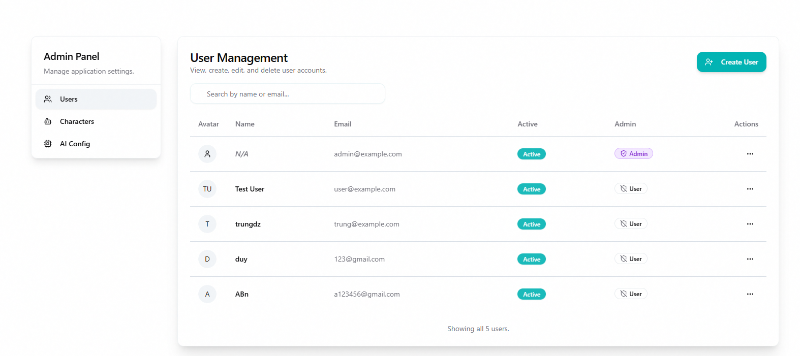

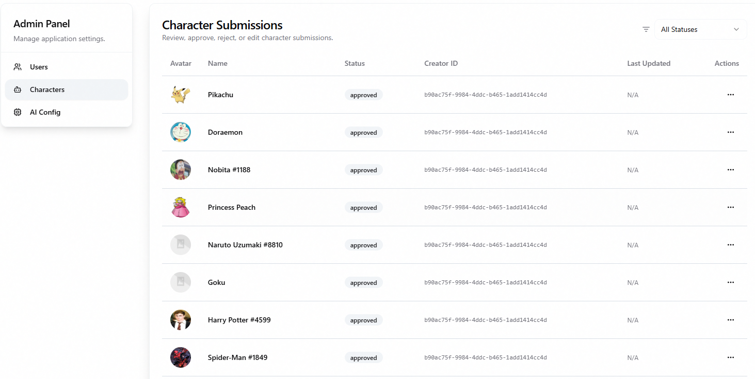

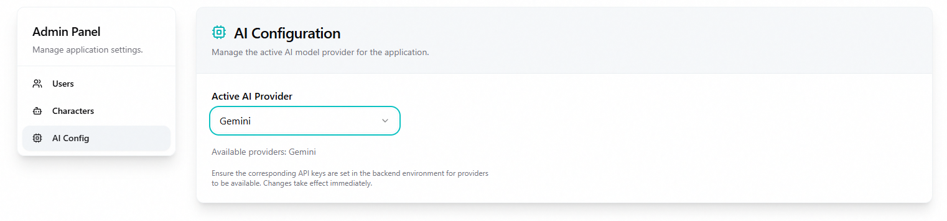

**3.7.3 Detailed Description of Components**

1. **AddUser**

| **ID** | **Field** | **Data Type** | **Input/Output** | **Initial Value** | **Description** |
| --- | --- | --- | --- | --- | --- |
| **1** | email | string | Input | "" | Email of the user, required and must follow valid email format |
| **2** | full_name | string | Input | "" | Full name of the user, optional |
| **3** | password | string | Input | "" | User password, required and must be at least 8 characters |
| **4** | confirm_password | string | Input | "" | Password confirmation, must match the password field |
| **5** | is_superuser | boolean | Input | false | Superuser permission, allows access to Admin module |
| **6** | is_active | boolean | Input | false | Account activation status |

1. **EditUser Component**

| **ID** | Field | Data Type | Input/Output | Initial Value | Description |
| --- | --- | --- | --- | --- | --- |
| **1** | email | string | Input | user.email | Email of the user, can be edited |
| **2** | full_name | string | Input | user.full_name | Full name of the user, can be edited |
| **3** | password | string | Input | "" | New password, optional when editing |
| **4** | confirm_password | string | Input | "" | New password confirmation, must match the password field |
| **5** | is_superuser | boolean | Input | user.is_superuser | Superuser permission, can be changed |
| **6** | is_active | boolean | Input | user.is_active | Account activation status, can be changed |

1. **UsersTable**

| **ID** | **Field** | **Data Type** | **Input/Output** | **Initial Value** | **Description** |
| --- | --- | --- | --- | --- | --- |
| 1 | page | number | Input | 1 | Current page number of the user list |
| 2 | PER_PAGE | number | Constant | 5 | Number of users displayed per page |
| 3 | users | UserPublic[] | Output | [] | List of users to display |
| 4 | count | number | Output | 0 | Total number of users in the system |

**3.7.4 Workflow**

Admin User Management

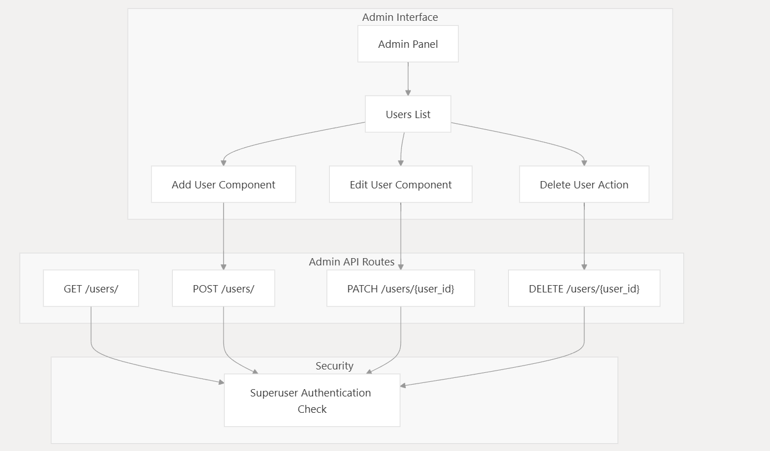

**4. COMMON AND REUSABLE DESIGN**

N/A

**5. APPENDIX**